
Data structure lab project
Banking Management System

May 17, 2026
MUHAMMAD.BILAL (FA24-BSE-023)
AHMED RAZA (FA24-BSE-013)
ISMAIL AHMED (FA24-BSE-024)

Code of Banking Management System
import java.util.Scanner;
// ------------------ Customer Class ------------------
class Customer {
int accountNumber;
String name;
double balance;
Customer(int accountNumber, String name, double balance) {
this.accountNumber = accountNumber;
this.name = name;
this.balance = balance;
}
public String toString() {
return accountNumber + " - " + name + " - Balance: " + balance;
}
}
// ------------------ Linked List for Transactions ------------------
class TransactionNode {
String transaction;
TransactionNode next;
TransactionNode(String transaction) {
this.transaction = transaction;
this.next = null;
}
}
class TransactionHistory {
TransactionNode head;
void addTransaction(String t) {
TransactionNode newNode = new TransactionNode(t);
if (head == null) head = newNode;
else {
TransactionNode temp = head;
while (temp.next != null) temp = temp.next;
temp.next = newNode;
}
}
void printHistory() {
TransactionNode temp = head;
while (temp != null) {
System.out.println(" -> " + temp.transaction);
temp = temp.next;
}
}
}
// ------------------ Stack for Undo Operations ------------------
class TransactionStack {
String[] stack;
int top;
TransactionStack(int size) {
stack = new String[size];
top = -1;
}
void push(String t) {
if (top < stack.length - 1) stack[++top] = t;
}
String pop() {
if (top >= 0) return stack[top--];
return null;
}
}
// ------------------ Queue for Customer Requests ------------------
class RequestQueue {
String[] queue;
int front, rear, size, capacity;
RequestQueue(int capacity) {
this.capacity = capacity;
queue = new String[capacity];
front = 0; rear = -1; size = 0;
}
void enqueue(String request) {
if (size == capacity) return;
rear = (rear + 1) % capacity;
queue[rear] = request;
size++;
}
String dequeue() {
if (size == 0) return null;
String item = queue[front];
front = (front + 1) % capacity;
size--;
return item;
}
}
// ------------------ BST for Account Lookup ------------------
class BSTNode {
Customer customer;
BSTNode left, right;
BSTNode(Customer customer) {
this.customer = customer;
left = right = null;
}
}
class AccountBST {
BSTNode root;
void insert(Customer c) {
root = insertRec(root, c);
}
BSTNode insertRec(BSTNode root, Customer c) {
if (root == null) return new BSTNode(c);
if (c.accountNumber < root.customer.accountNumber)
root.left = insertRec(root.left, c);
else if (c.accountNumber > root.customer.accountNumber)
root.right = insertRec(root.right, c);
return root;
}
Customer search(int accountNumber) {
return searchRec(root, accountNumber);
}
Customer searchRec(BSTNode root, int accountNumber) {
if (root == null) return null;
if (root.customer.accountNumber == accountNumber) return root.customer;
if (accountNumber < root.customer.accountNumber)
return searchRec(root.left, accountNumber);
return searchRec(root.right, accountNumber);
}
// NEW: Delete method
void delete(int accountNumber) {
root = deleteRec(root, accountNumber);
}
BSTNode deleteRec(BSTNode root, int accountNumber) {
if (root == null) return null;
if (accountNumber < root.customer.accountNumber)
root.left = deleteRec(root.left, accountNumber);
else if (accountNumber > root.customer.accountNumber)
root.right = deleteRec(root.right, accountNumber);
else {
// Node found
if (root.left == null) return root.right;
else if (root.right == null) return root.left;
// Replace with inorder successor
root.customer = minValue(root.right);
root.right = deleteRec(root.right, root.customer.accountNumber);
}
return root;
}
Customer minValue(BSTNode root) {
Customer min = root.customer;
while (root.left != null) {
min = root.left.customer;
root = root.left;
}
return min;
}
}
// ------------------ Bubble Sort ------------------
class Sorter {
static void bubbleSort(Customer[] arr) {
int n = arr.length;
for (int i = 0; i < n-1; i++) {
for (int j = 0; j < n-i-1; j++) {
if (arr[j] != null && arr[j+1] != null &&
arr[j].balance > arr[j+1].balance) {
Customer temp = arr[j];
arr[j] = arr[j+1];
arr[j+1] = temp;
}
}
}
}
}
// ------------------ Main Banking System ------------------
public class Bankingsystem {
public static void main(String[] args) {
Scanner sc = new Scanner(System.in);
// Step 1: Add 7 customers via Scanner
Customer[] customers = new Customer[3];
for (int i = 0; i < 3; i++) {
System.out.println("Enter details for Customer " + (i+1));
System.out.print("Account Number: ");
int acc = sc.nextInt();
sc.nextLine(); // consume newline
System.out.print("Name: ");
String name = sc.nextLine();
System.out.print("Balance: ");
double bal = sc.nextDouble();
customers[i] = new Customer(acc, name, bal);
}
// Supporting structures
TransactionHistory history = new TransactionHistory();
TransactionStack stack = new TransactionStack(20);
RequestQueue queue = new RequestQueue(10);
AccountBST bst = new AccountBST();
for (Customer c : customers) bst.insert(c);
// Step 2: Menu-driven system
int choice;
do {
System.out.println("\n--- Banking Menu ---");
System.out.println("1. View All Customers");
System.out.println("2. Add Transaction");
System.out.println("3. View Transaction History");
System.out.println("4. Undo Last Transaction");
System.out.println("5. Add Customer Request");
System.out.println("6. Process Next Request");
System.out.println("7. Search Customer by Account (BST)");
System.out.println("8. Sort Customers by Balance (Bubble Sort)");
System.out.println("9. Remove Customer Record");
System.out.println("0. Exit");
System.out.print("Enter choice: ");
choice = sc.nextInt();
sc.nextLine();
switch (choice) {
case 1:
for (Customer c : customers) if (c != null) System.out.println(c);
break;
case 2:
System.out.print("Enter transaction detail: ");
String t = sc.nextLine();
history.addTransaction(t);
stack.push("Undo: " + t);
break;
case 3:
history.printHistory();
break;
case 4:
System.out.println("Undo Operation: " + stack.pop());
break;
case 5:
System.out.print("Enter request: ");
String req = sc.nextLine();
queue.enqueue(req);
break;
case 6:
System.out.println("Processing Request: " + queue.dequeue());
break;
case 7:
System.out.print("Enter account number to search: ");
int acc = sc.nextInt();
Customer found = bst.search(acc);
System.out.println(found != null ? found : "Not Found");
break;
case 8:
Sorter.bubbleSort(customers);
System.out.println("Sorted Customers by Balance:");
for (Customer c : customers) if (c != null) System.out.println(c);
break;
case 9:
System.out.print("Enter account number to remove: ");
int removeAcc = sc.nextInt();
for (int i = 0; i < customers.length; i++) {
if (customers[i] != null && customers[i].accountNumber == removeAcc) {
bst.delete(removeAcc); // remove from BST too
customers[i] = null; // remove from array
System.out.println("Customer removed.");
break;
}
}
break;
case 0:
System.out.println("Exiting...");
break;
default:
System.out.println("Invalid choice!");
}
} while (choice != 0);
sc.close();
}
}

Output of The Banking Management System
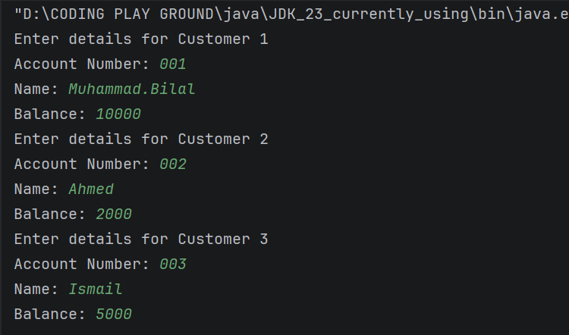

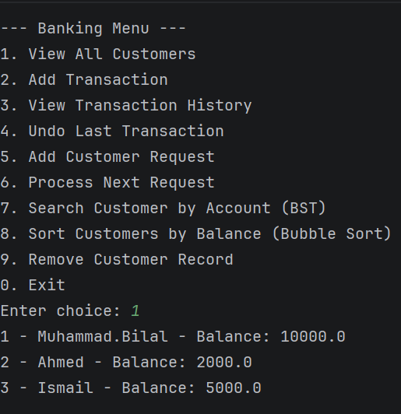

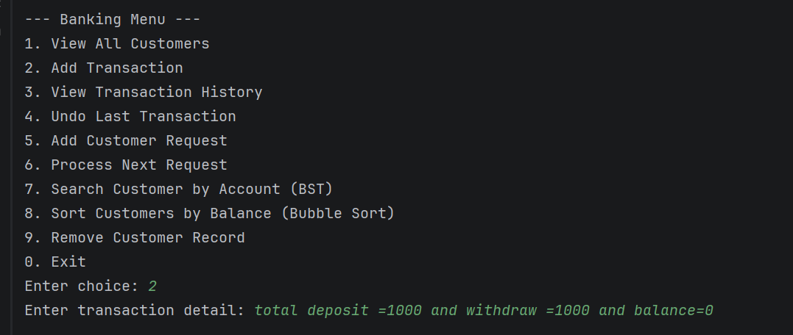
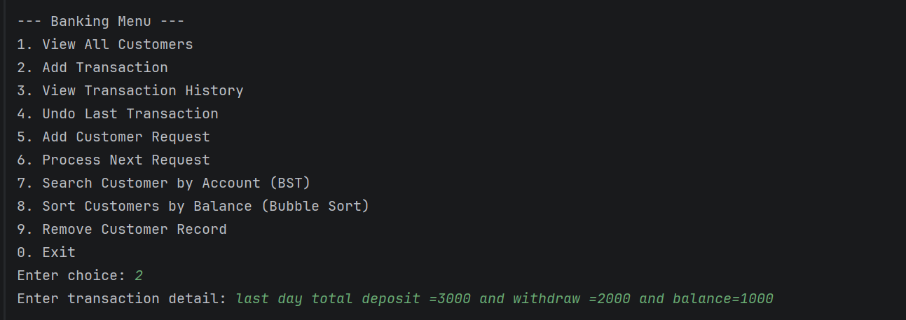

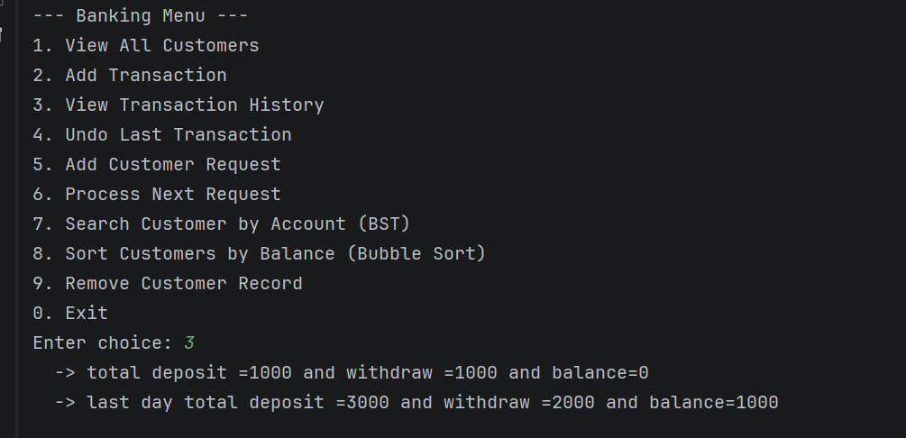
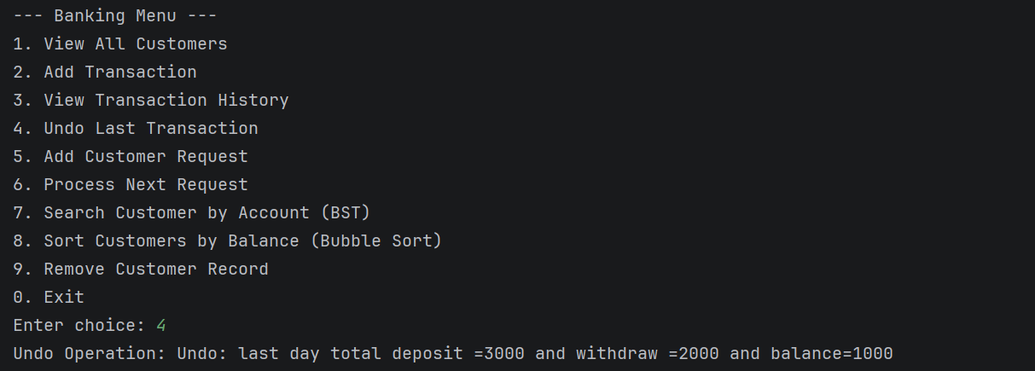
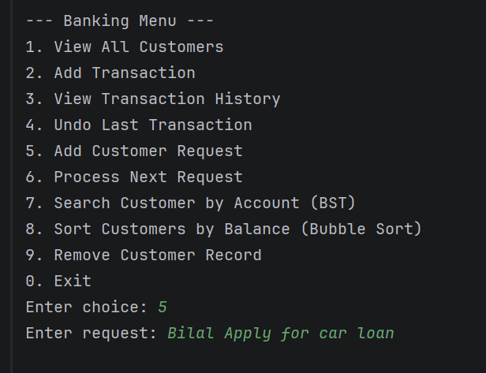
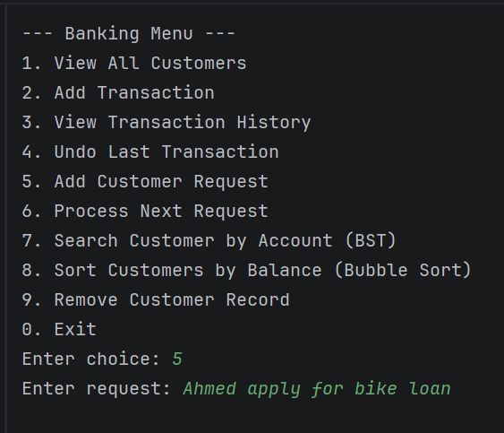
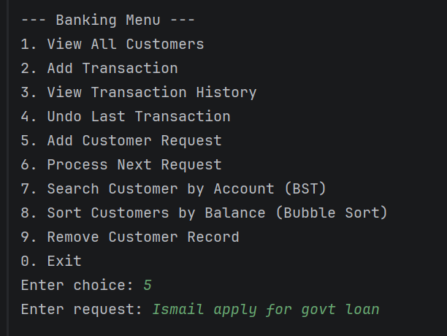
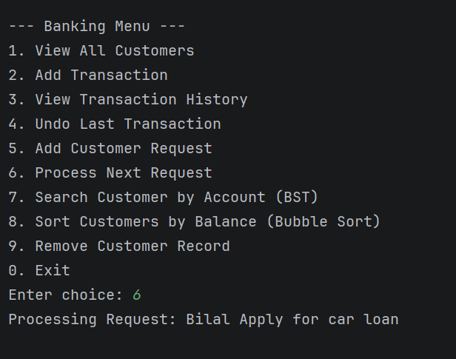
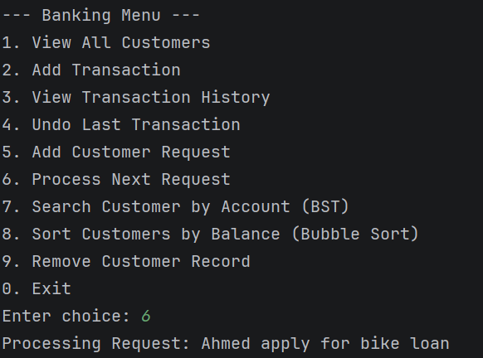
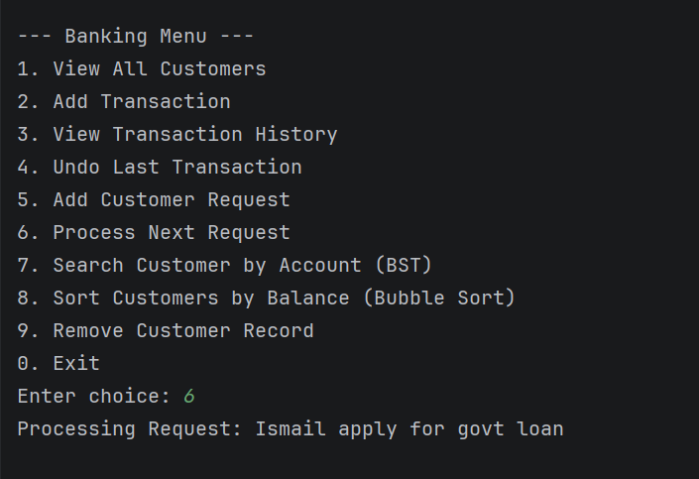
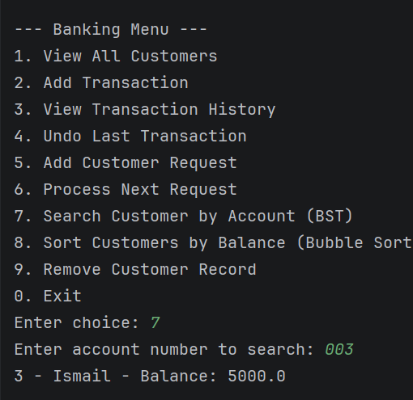
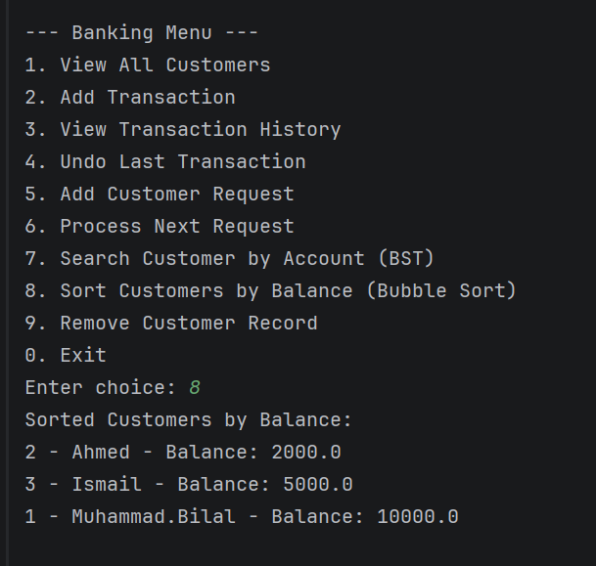

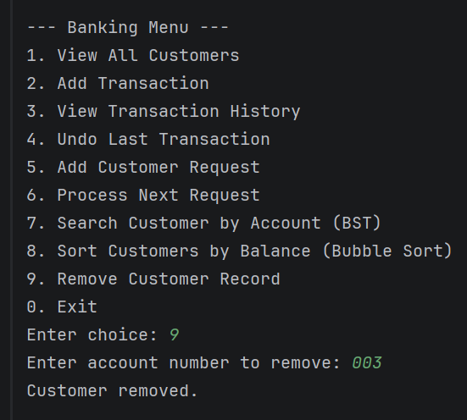

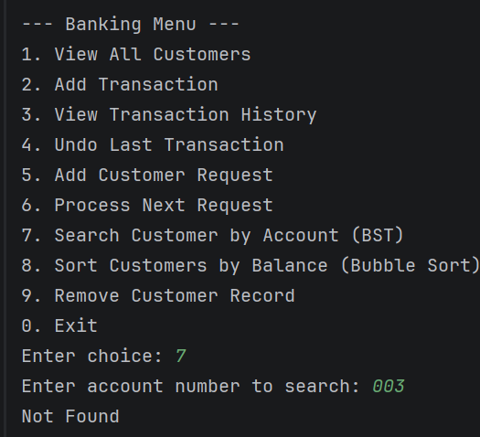
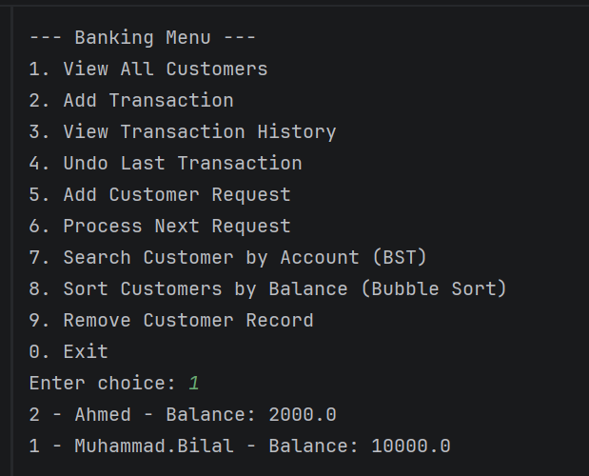
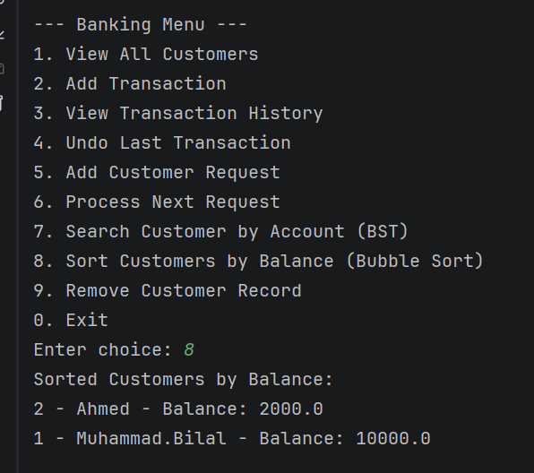
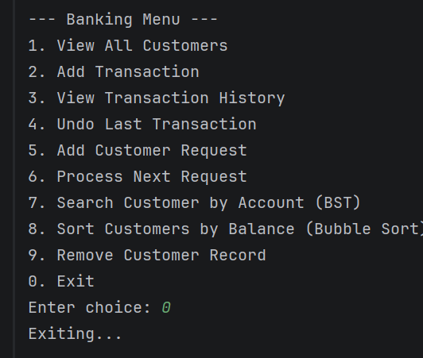
Explanation Of The Code of The Banking System

Introduction to the Banking System
The Banking Management System is a console-based Java project that simulates real banking operations like adding customers, transactions, searching, sorting, and removing records. It is designed to showcase core data structures and algorithms taught in class, applied in a practical context. The project helps demonstrate how theory connects to real-world applications, making it easy to defend in your semester presentation.

Data Structures Used

1. Array
- Stores all customer records in a simple list.
- Allows easy indexing, iteration, and printing of customer details.
- Used as the main container for customer data.

2. Linked List
- Maintains a transaction history for each operation.
- Provides sequential storage where new transactions are appended at the end.
- Used to show how past activities can be tracked.

3. Stack
- Records transactions for undo operations.
- Works on the LIFO (Last In, First Out) principle.
- Used to reverse the most recent transaction.

4. Queue
- Stores customer service requests in order.
- Works on the FIFO (First In, First Out) principle.
- Used to process requests one by one.

5. Binary Search Tree (BST)
- Organizes customers by account number.
- Allows fast searching, insertion, and deletion.
- Used to quickly find a customer record by account number.

6. Bubble Sort
- Sorts customers by balance in ascending order.
- Simple algorithm that repeatedly swaps adjacent elements.
- Used to demonstrate sorting in a banking context.

Banking Menu Explanation

1. View All Customers
- Shows all customer records stored in the array.

2. Add Transaction
- Adds a transaction to the linked list and stack for history and undo.

3. View Transaction History
- Displays all transactions stored in the linked list.

4. Undo Last Transaction
- Uses the stack to reverse the most recent transaction.

5. Add Customer Request
- Adds a request into the queue for later processing.

6. Process Next Request
- Dequeues and processes the next request in line.

7. Search Customer by Account (BST)
- Finds a customer record quickly using the BST.

8. Sort Customers by Balance (Bubble Sort)
- Sorts customers by their balance using bubble sort.

9. Remove Customer Record
- Deletes a customer from both the array and BST.

0. Exit
- Ends the program safely

